* Right click on Project > New > Python File.
* Enter File name >Hit Enter
* The file comes with .py extension.
* To print anything in console we type:

print(**"Hello World"**)

* Right click on the file and click Run ‘FirstDemo’.

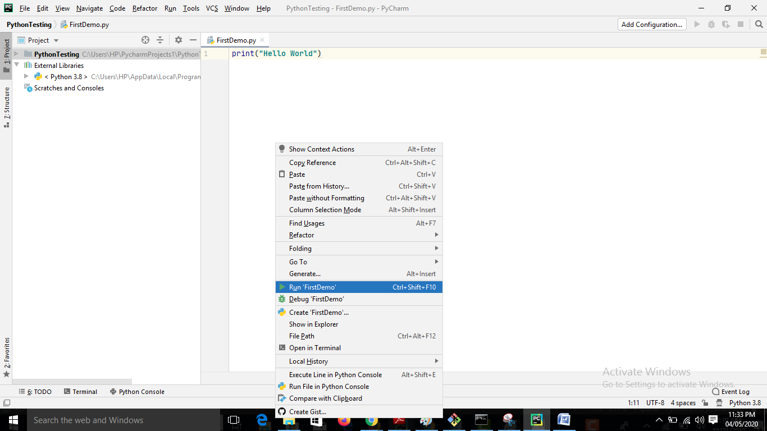

* Ctrl+Shift+F10 is the shortcut to run.
* To comment out use #.

Eg #this is a comment

* Create variable: a=3, that’s it. Python will automatically calculate the data type at run time.
* However data types exist in Python. But you may not mention it explicitly.
* Simple examples

print(**"Hello World"**)  
a=100  
print(a)  
  
Str=**"Hellow World"**print(Str)

Output:

C:\Users\HP\AppData\Local\Programs\Python\Python38-32\python.exe C:/Users/HP/PycharmProjects1/PythonTesting/FirstDemo.py

Hello World

100

Hellow World

* We can declare many variables in a single line:

Eg

b,c,d=6, 2.8,**"Great"**print(b,c,d)  
print(c)

* In python we don’t have colon (;) at the end.
* We have code indentation in Python.

*********